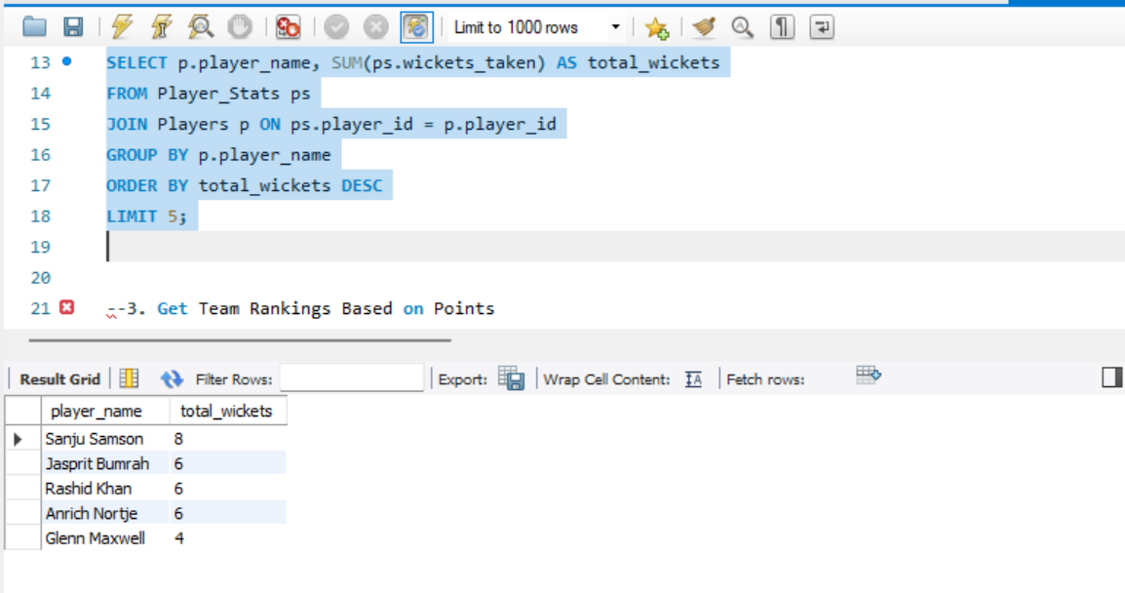

*Query 1. To find top 5 bowlers who highest wicket taken.*

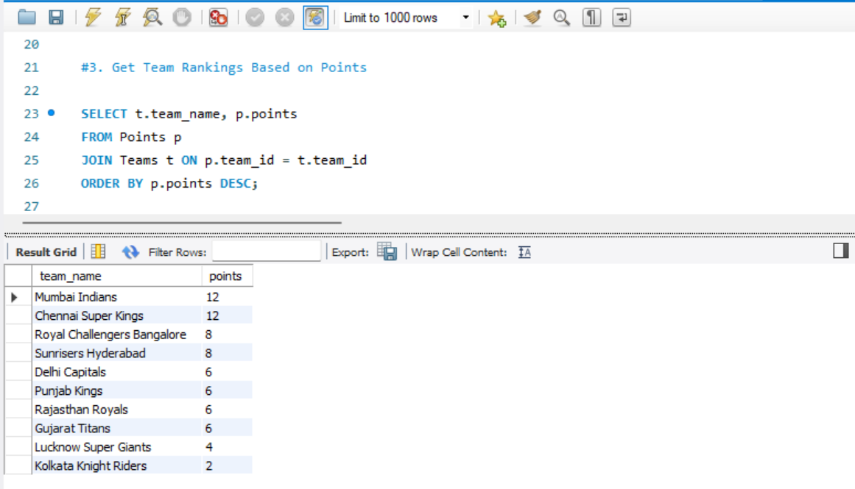 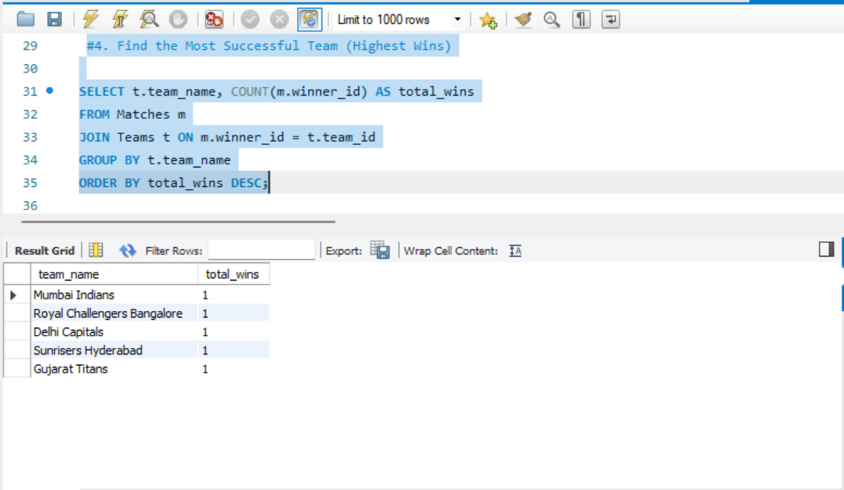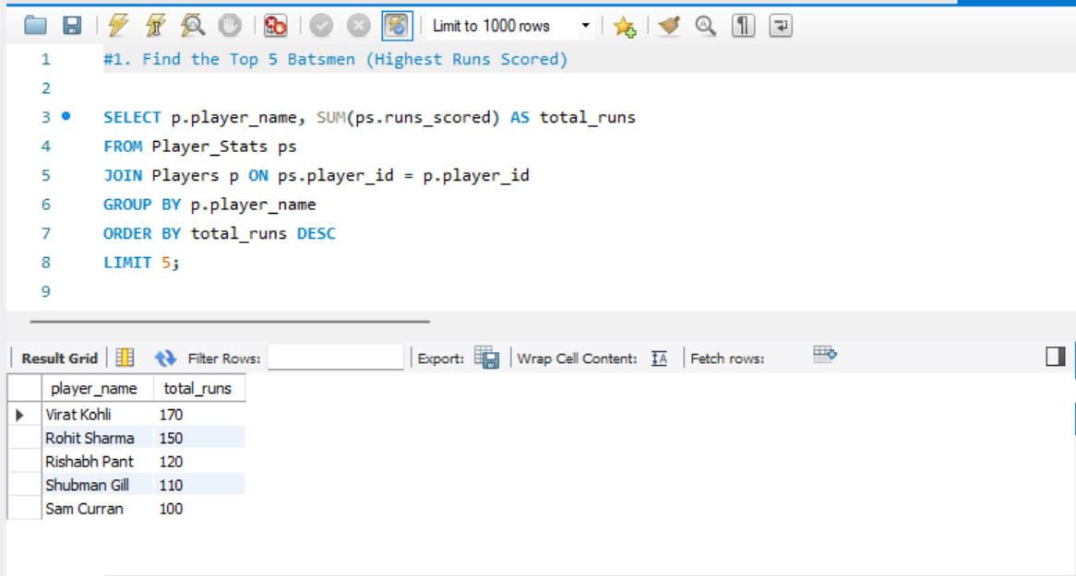

*Query 2. To get team rankings based on points.*

*Query 3. To find most successful team who win highest.*

*Query 4. To find top 5 batsman who highest scored.*